1-Page Summary Report

Problem Statement
Given heights and weights of 200 professional baseball players, build a simple linear model weight ≈ m · height + b that can be used for prediction and interpretation. The educational goal is to implement the model both from scratch (gradient descent on squared-error loss) and with scikit-learn, then compare methods and explore sensitivity to learning rate, noise and sample size.

Solution Strategy
1. Explore the data and visualise the height–weight scatter. 2. Define loss as sum of squared residuals. 3. Derive analytic gradients of loss w.r.t. slope and intercept. 4. Implement iterative gradient descent (with a centering trick for numerical stability). 5. Verify against the closed-form normal equations and sklearn LinearRegression. 6. Diagnose residuals and run Monte-Carlo simulations that vary learning rate, additive noise and sample fraction. Audience-aware reporting language is prepared for technical, domain-expert, executive and non-specialist readers.

Solution
Key numerical results: slope m ≈ 3.43 lb per inch, intercept b ≈ −106, R² ≈ 0.31. From-scratch centered gradient descent, the closed-form solution and sklearn agree to four decimal places. Residual plots show no strong systematic pattern; residual mean is essentially zero.
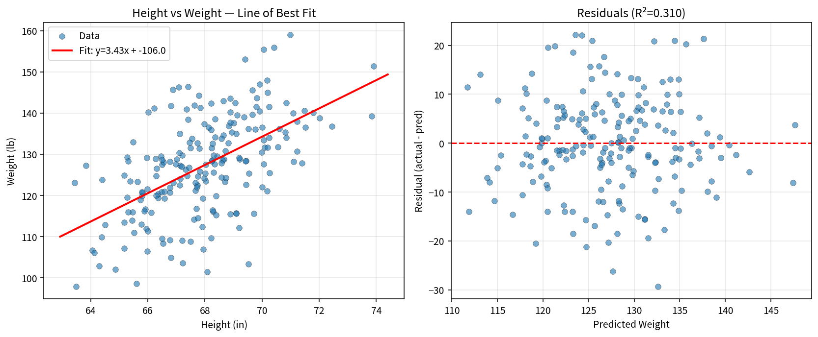
Interpretation for different audiences: Technical — method agreement and residual diagnostics. Executive — “Each extra inch of height is associated with roughly 3.4 lb higher weight; height explains about 31 % of weight variation.” Non-specialist — a simple upward-sloping line through a cloud of points that shows taller players tend to be heavier.

Key Takeaways
• The line of best fit minimises average squared loss; lower loss is always better on the same data.
• Gradient descent moves parameters opposite the gradient of loss; learning rate controls step size (too small → slow; too large → divergence).
• Centering predictors and response dramatically improves GD stability for variables on different scales.
• sklearn, closed-form and a correctly implemented GD recover the same coefficients for simple linear regression.
• Always adapt charts and language to the audience’s data literacy and subject knowledge (experts vs non-specialists, executives vs technicians).
• R² ≈ 0.31 indicates height is a useful but incomplete predictor of weight; many other factors remain.

